14.27: a) The pressure at the top of the block is 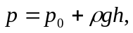where is the depth of the top of the block below the surface. is greater for block , so the pressure is greater at the top of block .
b)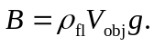 The blocks have the same volume 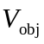so experience the same buoyant force.
c) 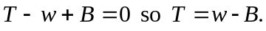

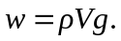 The object have the same but is larger for brass than for aluminum so is larger for the brass block. is the same for both, so is larger for the brass block, block